EXP 2: Simulation and Performance
Evaluation of People–Process–Data–Things IoE Framework using Edge/Fog-to-Cloud Pipeline

Objective: To simulate and evaluate a People–Process–Data–Things (PPDT) Internet of Everything (IoE) framework using an Edge/Fog-to-Cloud pipeline to improve data processing efficiency, reduce latency, optimize bandwidth usage, and enhance system performance, reliability, and scalability.
Procedure:
- Design the PPDT-based IoE framework.
- Simulate IoE devices generating real-time data.
- Process data at the Edge and Fog layers.
- Transfer processed data to the Cloud for storage and analysis.
- Evaluate latency, throughput, bandwidth, and energy efficiency.
- Compare the results with a cloud-only approach.
- Analyze the results to assess overall system performance.

Number of sources: 2
 | Edge | Fog | Cloud
Propagation delay | 2 | 10 | 40
Processing delay | 4 | 8 | 16
Queueing delay | 1 | 3 | 6
End to end | 8.159ms | 22.15ms | 63.15ms
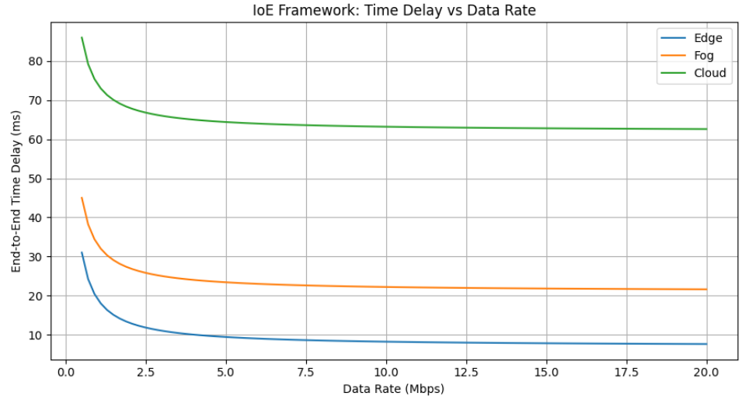
Number of source:15
 | Edge | Fog | Cloud
Propagation delay | 15 | 75 | 300
Processing delay | 30 | 60 | 120
Queueing delay | 7.5 | 22.5 | 45
End to end | 53.659ms | 158.659 ms | 466.159

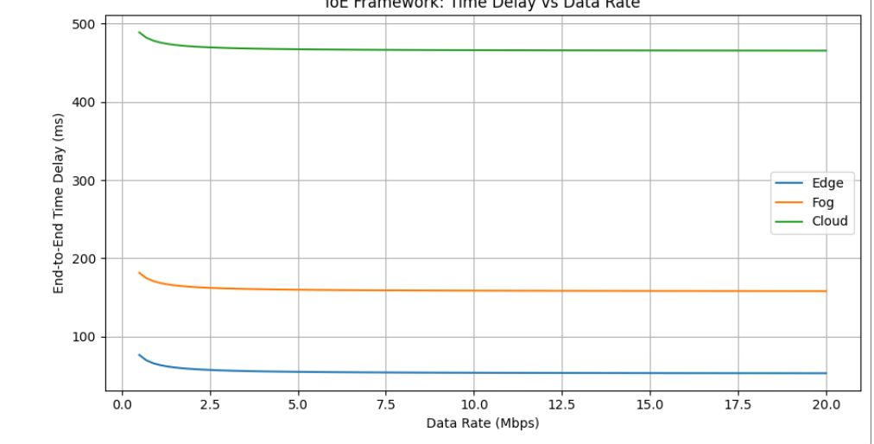
Result:
Edge computing provides the lowest end-to-end delay compared to Fog and Cloud for both 2 and 15 sources. As the number of sources increases, delay also increases. Therefore, Edge is best for real-time IoE applications, Fog provides moderate performance, and Cloud is suitable for large-scale data processing.

